The civilization of China has some of the oldest written records that have ever been discovered dating back over 4,000 years. While over time the characters and symbols have been modified and changed, there is much that can be learned from these early writings. Within the characters and word pictures of Chinese writing, there are stories within the stories. It is interesting how the words created thousands of years ago apply to the world we have today.

Are you happy? If not, would you like to be happy? All over the world, people are looking for. People search for it in many ways. The seek happiness in pleasure, sex, music, drugs, money, power, philosophy, education, books, religion and many other ways. But very few men and women ever find true peace and happiness.

Happiness? What is it? We all want it. We all search for it. Why is it so hard to find? Could it be we are looking for it in all the wrong places? If so, then where should we look? Why not start at the beginning.

The recorded history of man dates back only about 6,000 years but how old is the earth? Some scientists believe the “Big-Bang” theory where all matter of the universe was compressed into a small ball and then a great explosion happened and the result was the creation of the heavens and the earth - separating the Light from the Darkness. The Christian Bible says that God formed the earth and all things. While the Bible is not written as a scientific text, it does offer another explanation: It says, ”and God created the heavens and the earth and separated the light from the darkness.” Albert Einstein also believed the cosmos, as we know it, was planned by a Supreme Intelligence, a mind so wonderful that it would be impossible for a man to comprehend. When we look at the world and all the things man has created and discovered, we can also see that there are still many mysteries yet to be discovered.

How did man appear on the Earth? Where did he come from? Who made man? Man is certainly the most intricate, most complex of all living things, more complex than computers or rocket ships. Even more amazing is the creation of male and female – both so unique and different yet both are required to join for the creation of a new life. What a miracle. How could two different complex organisms develop at the same time and at the same place so as to continue and reproduce? Well, there is a story about how thousands of years ago, a Supreme Being made the first and the first man and woman and put them in a beautiful garden in a state of complete happiness.
This Supreme Being, whom men call God, by various names, has revealed himself in many ways: in creation of plant and animal life; in the heavens, stars, constellations, and in the structured order of all things. It is most fascinating that God even revealed Himself through the language. By the examination of a few words, we can see how God desired to have a relationship with the people of the world.

This will only be a brief study into some of the words God gave the people. Let’s examine the word “CREATE”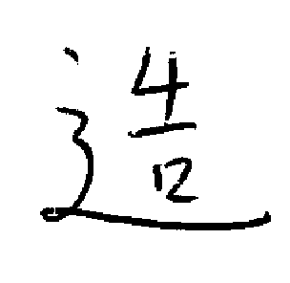. The true meaning of this word is revealed in its components:
is ‘dust”, which is a “mouth” or speak and which is P’ieh which means “life / breath or spirit”. The final component 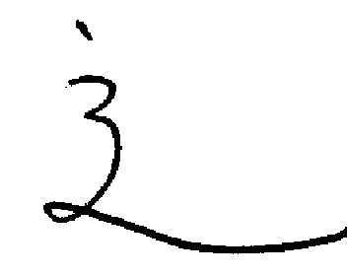 means “to walk”. When you put the four characters together, the final Chinese word is “create”.

But, how does the work “create” reveal to the Chinese people how God revealed Himself? Over 3,500 years ago, the Hebrew prophet, Moses recorded in the Bible: And the Lord God formed man of the dust of the ground and breathed into him, the breath of life and man became a living soul. (Genesis 2:7) The same words Moses used are the same as the Chinese character!

The Bible continues that God created man in a condition of happiness.
The Chinese word for happiness has 4 parts: “God”; is ‘first or one”; “mouth” and “garden”. Moses continues in Genesis 2:8-9 that “And the Lord God planted a garden eastward in Eden and there he put the man and women whom He had formed. And out of the ground the Lord God created every tree that is pleasant to the sight and good for food: the tree of life also in the middle of the garden, and also the tree of knowledge of good and evil.”

God made a beautiful garden for the man whom He created. Man had everything he wanted to eat, a beautiful place to live and nothing to fear. He was happy and content. To remain in this state of happiness all man had to do was obey God: “And God took the man and put him in the garden of Eden to watch over and keep it. And the Lord God commanded Man , saying Of every tree of the garden you may freely eat, But of the tree of knowledge of good and evil, you shall not eat from it; for in that day you will surely die (Genesis 2:15-17)
To complete man’s happiness, God made for him a wife. The Bible says “and the Lord God said it is not good that the man should be alone; I will make him a helper (wife) … and the Lord God caused a deep sleep to fall upon Adam, and he slept; and he took one of his ribs, and closed up the flesh, and from the rib, the Lord God made a women, and brought her to the man. And Adam said, “This is now bone of my bones, and flesh of my flesh; she shall be called women because she was taken out of the Man. For this reason, a man shall leave his father and his mother and shall join with his wife and they shall be one”. (Genesis 2:18-24)

Is there evidence in the Chinese language to indicate this story is true? Consider the word WIFE This word is made up of the following parts: which means a border or enclosure; means “enter” or “enter in” The character for flesh is which also contains the same word for “Border” and “to enter” and add for “person” God made woman from man to be his wife 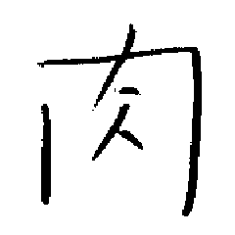 to enter into a closed relationship as one flesh. Both the man and his wife lived in the garden with God in perfect happiness.

But something happened to bring sorrow and the man and his wife were no longer happy. The reason for their unhappiness is also told in the Bible, Genesis 3:1-6: Now the serpent (an evil spirit in the form of a snake) was more subtle than any beast of the field which the Lord God had made. And he said to the women, “Did God say not to eat from every tree in the garden?” And the women said to the serpent, we may eat of the fruit of the trees of the garden, but of the fruit of the tree in the middle of the garden, God said that we should not eat it or touch it – or we would die. And the serpent said to the women, you shall not die, for God knows that in the day you eat from the tree, your eyes will be opened, and you will be like God and know Good from Evil. And when the women saw the tree was good for food, and was pleasant to the eyes, and the tree would make her wise, she took some fruit and ate it, and she gave some to her husband and he also ate some.

The Devil as a serpent came and deceived Eve; Eve, then caused Adam to disobey God. The English word for disobeying God is ‘SIN”. As God had warned them, they were cast out of the beautiful garden. God then told them that the women would bear her children in sorrow and that man would have to work hard for his food; unhappiness would be their condition in life until they died and returned to the dust of the earth from which god had created them from.

Another word in the Chinese language for garden is 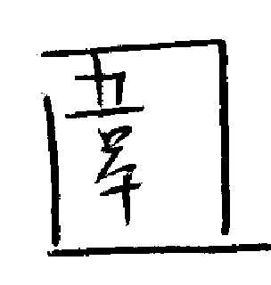. The characters that make up this word are “dust; “mouth”; “perfect and handsome couple”. Thus, the perfect and happy couple sinned and God spoke and commanded that they had to be cast out of the garden, die, and return to dust. This horrible thing happened to the first family because they were deceived by the Devil.

The word for Devil is also very interesting: This word includes the characters “garden”; “man or the human nature” of the Devil to speak as a man; meaning “private or secret” and “p’ieh” which means the Devil is alive, and a real being. So, 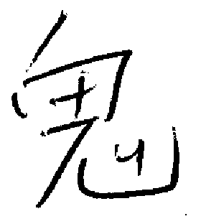, the Chinese word for Devil indicates that the story in the Bible is true. The devil secretly disguised himself in the garden and deceived the first women as he spoke like a man.

Another word for the Devil in the Chinese language is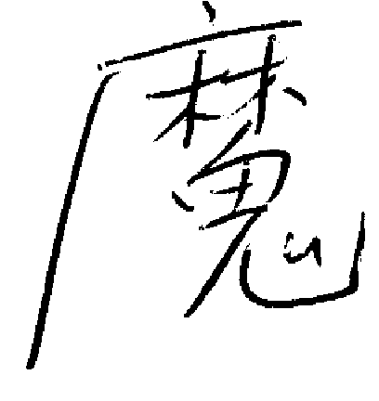. This word also means ‘Tempter”. Just as the Devil caused the first man and the first women to disobey God, this evil one tempts everyone to sin. The word picture for ‘tempter’ is made by placing the word for Devil under the cover of two protecting trees. Remember that in the garden there were two trees; the ‘Tree of Life’ and the ‘Tree of knowledge of good and evil’. It was in the two trees where the Devil, disguised as a serpent, hid and waited for the woman to come and gather fruit. The Chinese language developed before the Bible was written provides evidence that it is true.

Because the first man and women sinned against God and were caught in the lie of the Tempter, they were cast out of the garden and sorrow and unhappiness has been the curse of mankind ever since.

So you must be asking, how can men and women ever regain eternal happiness? Can people be forgiven by God for their sins? According to newer pasts of the Bible written between 2000 BC and 100 AD), the answer is YES!

Many religions of the world require their believers to atone for their sins by making offerings to their god or gods. The most acceptable offering for sin has bee the sacrifice of an animal. The prophet Moses continued to write in the Bible in Leviticus 9:2 Take a bull calf for a sin offering and a ram for a burnt offering, both without blemish and offer them before the Lord. The Chinese word for a sacrificial animal is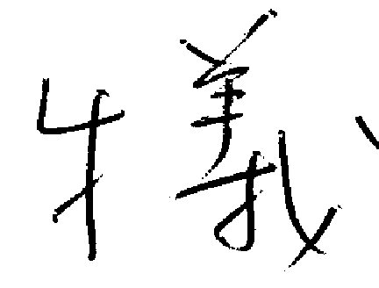. The animals specified to be sacrificed for evil deeds (sin) are a lamb and a bull calf (ox). As in the Bible, these beasts must also be unblemished or beautiful.

People have offered sacrifices for thousands of years. The reason for these sacrifices was for men and women to become righteous before God. This means to have their sins forgiven: to stand ‘Right” before the Lord. The Chinese word for righteousness includes the parts: meaning “a sheep or Lamb”. Beneath the lamb is depicting “I, me, or we” kneeling before it. Further inspection of this character reveals a composite figure of a hand and a lance or spearhead. The overall meaning of the word for RIGHTEOUSNESS is that a sinful man can become righteous again by the killing of a sacrificial lamb by his own hand.

This is also told in God’s Word in the Bible, especially in the book of Hebrews in the New Testament of the Bible, but there really was no lasting forgiveness by God to man in the sacrificial animals. Sacrifices were only a symbol of the true offering for sin, “THE LAMB OF GOD”. All through the Old Testament of the Bible, there is reference to a sacrificial Lamb, or a person called the Messiah. Two thousand years ago, such a person was born. He is the Son of God who came to sacrifice Himself for the sins of mankind. The book of John(1:29) reads …Behold, the Lamb of God which takes away the sin of the world. This Lamb is Jesus Christ who lived on earth for thirty-three years. According to the Bible and other records, Jesus Christ preached a new message of faith and love; He healed the sick and raised the dead. Because Jesus was feared by both religious and political leaders, He was crucified (hung on a cross) But, the Chinese Character for righteousness, it is you and I (and everyone else) who really killed the Son of God, because He died for each of our sins. But, as the Bible declares, Jesus Christ was buried, and on the third day he arose from the dead and later ascended into Heaven to become the Savior of all who believe (and trust) in Him.

Here is another example of three Chinese characters: “The Tree”, “The Lamb” and “eternal (water)” are united into one glorious phrase meaning “example” or “pattern”. This pattern illustrate the happy end of God’s story of redemption, In the last book of the Bible, Revelation, there is a message of a glorious future for all who believe in Jesus Christ – eternal life with Him in Heaven. Christians believe that Jesus Christ is the Ruler of eternity. He is the center in which Time is defined: BC (Before Christ) and after his birth A.D. (Anno Domini – Latin for “In the Year of the Lord of the Christian era”).

One final word to consider is the word “COME” .
This word is made up of three parts: The center of the word is the word for Tree or Wood. Hanging on the sides are two small men and in the center could be a large man. When these characters are combined, they tell us to come. The Bible says Jesus was hung on a cross of wood (A tree) and beside Him were two criminals – one on his left and one on his right. The reason Jesus died was to pay the penalty for our sin against God.

I hope these words give you an understanding about the creation of man, the reason for our fall into sin and how God gave you a gift of salvation through his son, Jesus Christ, the sacrificial Lamb, who died on the cross as an atonement and penalty for our sins. All that is required is to believe in the Lord Jesus Christ and He will give you peace and true Happiness. By becoming a child of God, you will added to His family and restore the relationship with God, the Father, that was broken long ago.

